|  |  |
| --- | --- |
| **PROJECT NAME.** | **DATE SUBMITTED** |
| Unlock OKR | 07/05/2021 |
| **PROJECT OBJECTIVES** Describe the high-level goals of the project and how they relate to overall business objectives. | |
| The Goal is to achieve the required UI designs as per the requirements using syncfusion within the agreed timelines. | |

## 1. Project Deliverables

Workable Alignment Map with all the below requirements fulfilled. The codebase should be checked-in to the repository every day, make sure it doesn’t break the build.

|  |  |
| --- | --- |
| **DELIVERABLE NO.** | **DESCRIPTION** |
| 1 | Map card with left and right icons should connect to previous & next okr card respectively. |
| 2 | Reverse connector implementation to connect the previous okr card. |
| 3 | Key results listed inside okr card should have required animation. |
| 4 | Multiple expand & collapse icons can appear for left or right connections as in design. |
| 5 | KR to KR connectors implementation as per the designs |
| 6 | Tags with text overlay on the connectors |
| 7 | The canvas should grow based on the area required by the diagram, without a scroll. |
| 8 | When zoom in out the context menu should also get changed as per the zoom ratio. |

## 2. List of Project Usecase

**Design Requirement 1:**

We have a business case where we need a tree to open from both the side of the card. As shown in the picture below there is a need to have an option on the same card where we can click and the trees will expand in each direction left as well as right.

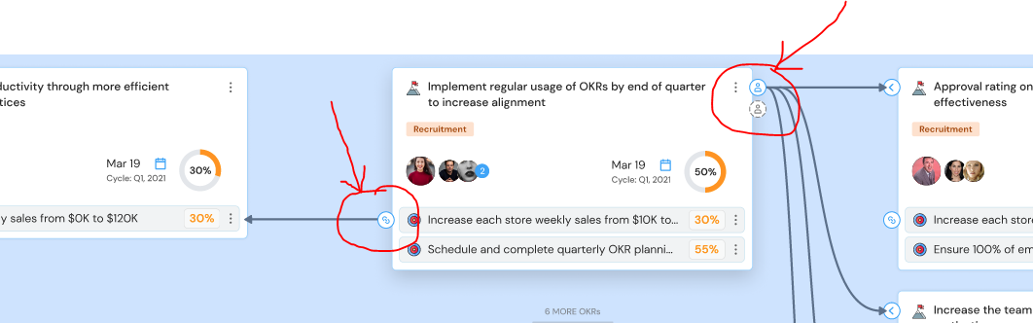

**Design Requirement 2:**

1. We have another business case where a card will have sub cards and the sub cards will also have its relation with other sub cards. And upon clicking the sub cards the parent cards relations will faint out and the sub cards relations will be highlighted.
2. Number Tag should be shown on the tip of the connector.

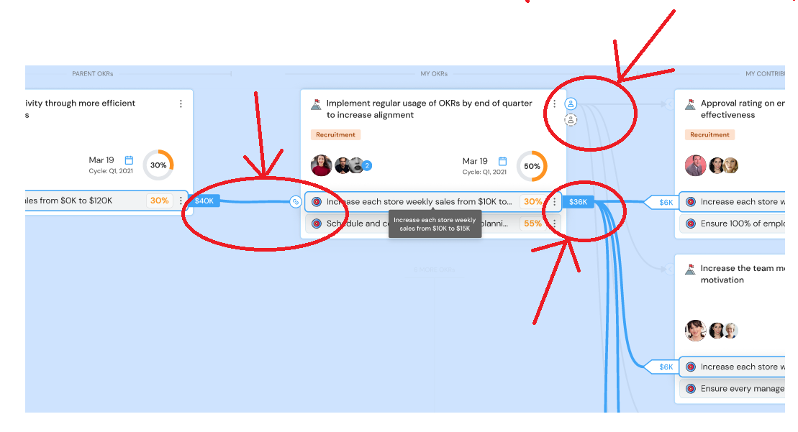

**Design requirement 3:**

Locate me option needs to be implemented as shown below.

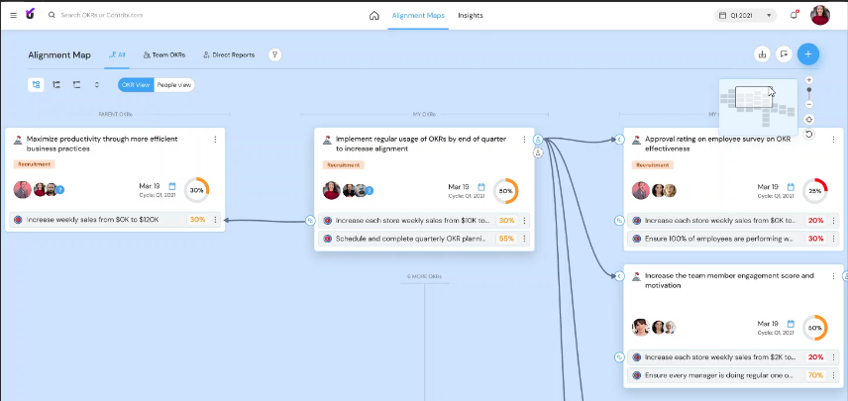

## 3. List of Project Tasks

|  |  |  |
| --- | --- | --- |
| **TASK NO.** | **DESCRIPTION** | **FOR DELIVERABLE NO. …**  **ENTER TASK #** |
| 1 | Setup OKR codebase on your local machine |  |
| 2 | Explore & Implement the Reverse connector for alignment maps using syncfusion. |  |
| 3 | Implement left icon for expand collapse of left Objective card |  |
| 4 | Implement One to multiple connections between the objective card. |  |
| 5 | Implement the highlighted view of key results inside the objective card and fade out of objective cards as per design 2. |  |
| 6 | Explore & Implement the blue connectors between the key results of one card to key results of another card as per design. |  |
| 7 | The canvas should have three columns on the screen at a time, Align the current user objective in center and parent on the left & child on the right as positioned in JSON as per design 3. |  |
| 8 | Locate me option needs to be implemented as per design 3 |  |
| 9 | Pop-ups in the diagram hide behind the cards (Z-index issue) |  |
| 10 | Implement blue tags with text at both the end of kr connectors |  |

## 4. Out of Scope

|  |  |
| --- | --- |
| This project will NOT accomplish or include the following: | * POCs code is not required if it’s implemented in OKR codebase. * Objective card creation and design which is already in place. |

## 5. Project Assumptions

|  |  |
| --- | --- |
| NO. | ASSUMPTION |
| 1 | Syncfusion has the capability to reverse the direction of arrow. |
| 2 | Key results inside the objective card can be connected to other key results in syncfusion. |
| 3 | We are using Complex Hierarchical Tree with REACT Framework |

## 7. Cost & Effort

|  |  |  |  |
| --- | --- | --- | --- |
| # | **Design Requirement** | **Effort in Hrs** | **Cost in INR** |
| 1 | Explore & Implement the Reverse connector for alignment maps using syncfusion. | 16 (If syncfusion layout will not work, it may take some more time.) |  |
| 2 | Implement left icon for expand collapse of left Objective card | 15 |  |
| 3 | Implement One to multiple connections between the objective card. | Diagram has default support for this. If any customization need will estimate. |  |
| 4 | Implement the highlighted view of key results inside the objective card and fade out of objective cards as per design 2. | 24 |  |
| 5 | Explore & Implement the blue connectors between the key results of one card to key results of another card as per design. | 24 |  |
| 6 | The canvas should have three columns on the screen at a time, Align the current user objective in center and parent on the left & child on the right as positioned in JSON as per design 3. | 20 (if any issue in diagram scroll will take some more time for workaround) |  |
| 7 | Locate me option needs to be implemented as per design 3 | 12 |  |
| 8 | Pop-ups in the diagram hide behind the cards (Z-index issue) | 16 |  |
| 9 | Implement blue tags with text at both the end of kr connectors | 24 |  |

## 8. Approvals

|  |  |  |  |
| --- | --- | --- | --- |
| **STAKEHOLDER NAME & TITLE** | **ROLE OF STAKEHOLDER / APPROVER** | **DATE SUBMITTED FOR APPROVAL** | **DATE APPROVAL RECEIVED** |
| Sagar | Client |  |  |
| Yadnyesh | Client |  |  |
| Rajesh | Vendor |  |  |